|  |
| --- |
| ID: 2024458 |
| Class: CSCI 2125-001 |
| Due: 9/30/2011 |
| Assignment: Homework 2, Part II |

ID: 2024458

Class: CSCI 2125-001

Date: 9/30/2011

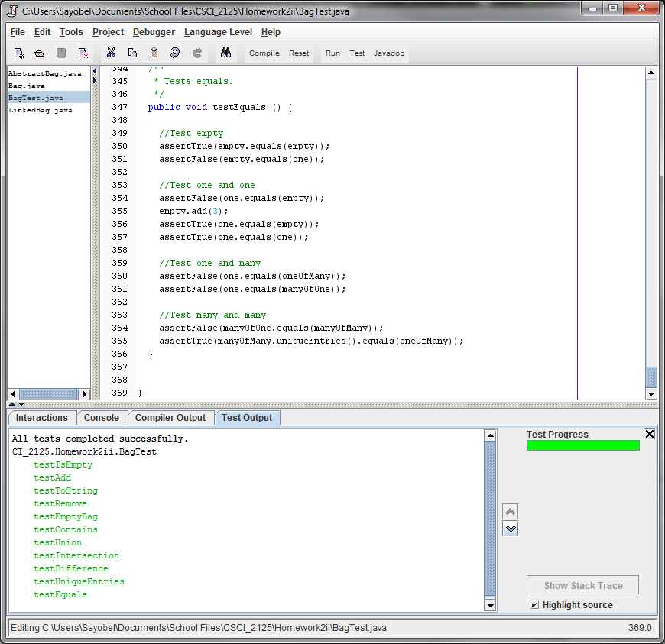Assignment: Homework 2 Part II